Hunter St.

47
Clifton St.

45

Winfield St.
Cleveland St.
Jefferson Ave.

27 28
8

LE GEND
32 Visitor Parking*
33 Accessible Parking
a Open Parking
Sidewalk
31 Field, Garden
Building

* Visitors are welcome to park in any Open Parking spaces if visitor parking is full.
30
1 Ellis Hall
2 Fausett Hall
3 Buhler Hall
4 Donald W. Reynolds Center for Life Sciences
5 Butler Plaza & Pecan Court
6 Charles D. Morgan Center for Physical Sciences
a John H. Reynolds Hall
b Acxiom Hall
7 Bertie Wilson Murphy Building
8 Bailey Library
9 Mills Center for Social Sciences
10 Costume Shop
11 Cabe Theatre
12 Staples Auditorium

← 44 41
← 45
29 34 35

26 36
13 Greene Chapel
14 Trieschmann Building
15 Reves Recital Hall
16 Art Buildings

← 46 42

42
b 25
24
40
17 Hendrix Corner Apartments
18 Front Street Apartments
19 Language House
37 20 Hardin Hall
21 Residence Houses

10 9

11
6 7
a

5

39 40

38
a Dickinson b McCreight c Browne
d Cook
e St4e0lla B. Smith
f Brown

12 4 22
23
22 Couch Hall 40
23 Martin Hall

n Ave.
Sutton St.
13
f
3
a b
14 20 21

Siebenmorgen Rd.

40 →
24 Student Life & Technology Center
25 Hulen Hall
26 Veasey Hall
Factory St.
Hamilton St.
27 Raney Hall
28 Galloway Hall

c d
15 2
e

1
Harrison St.

Spruce St.
Clayton St.
29 Raney Building
30 Outdoor Tennis Courts
31 Market Square South
32 Market Square North
33 Market Square East

Spruce St.
Markham St.
Spencer St.

19

Pine St.

18

16
Front St.
16
16

Switchboard
501-329-6811

Public Safety
501-450-7711
a Village Books
34 Facilities Management
35 Indoor Tennis Courts
36 Sturgis Center
37 Aquatics Center
38 Wellness and Athletics Center
39 Young-Wise Memorial Stadium
40 Athletics Fields
41 Public Safety
42 Technology Services
43 Health and Counseling
44 Huntington Apartments
45 Clifton Street Apartments
46 Eco House

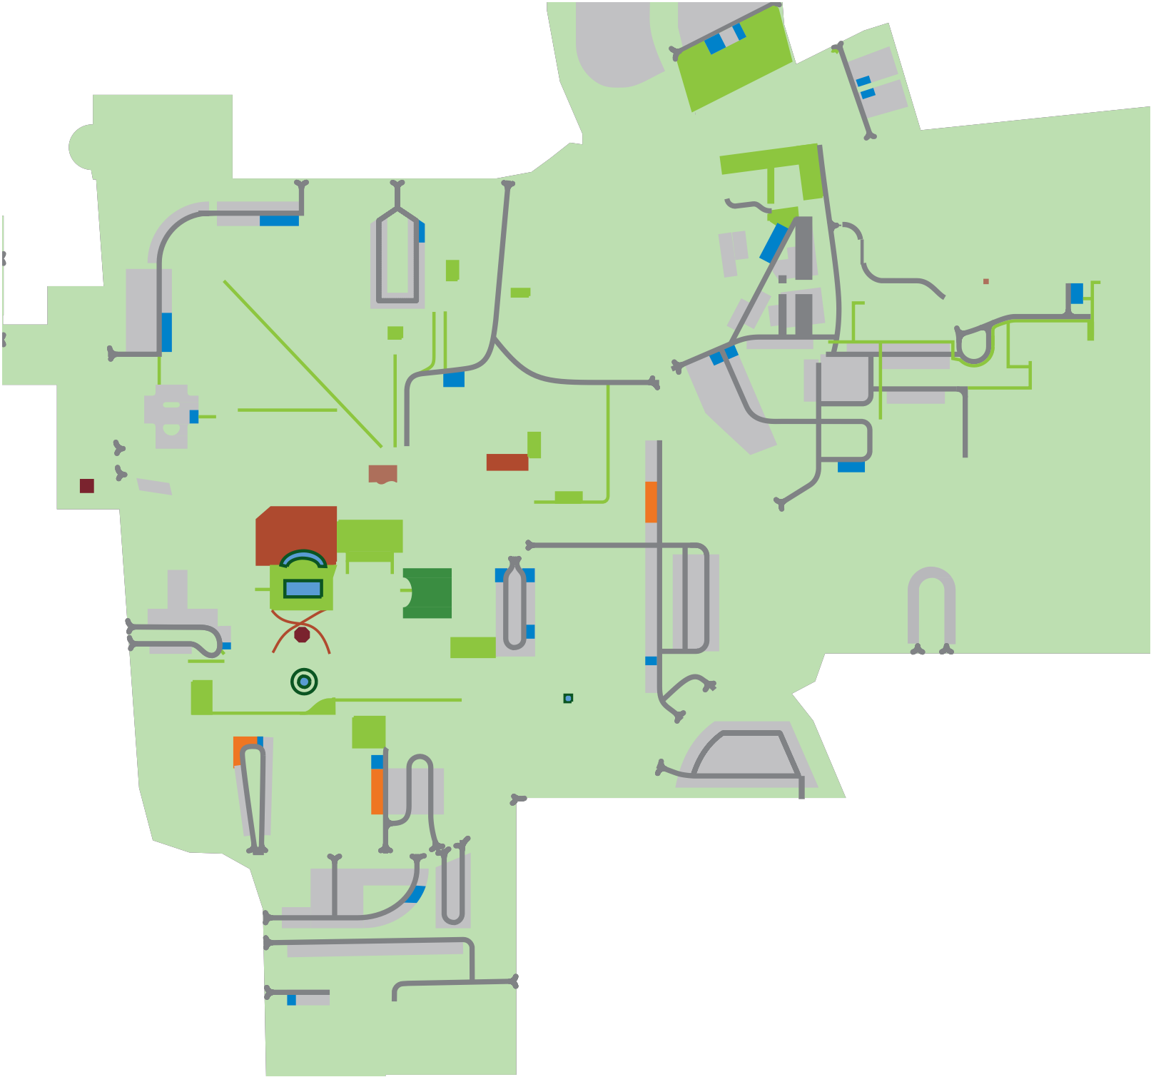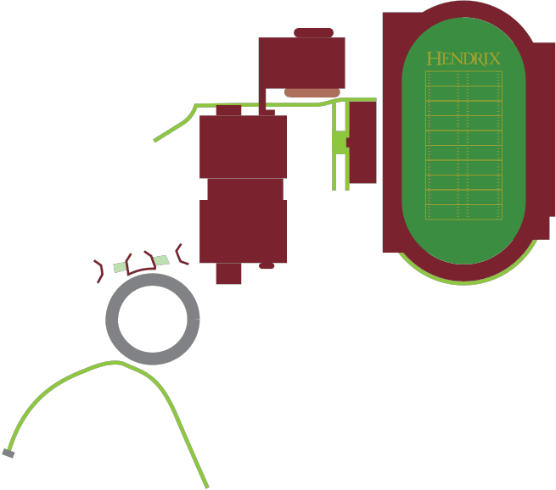17 ↓
Lincoln St.
Altus St.
McKennon St.

17
Walnut St.
47 President’s Home

