Resistor Circuits Lab

In this lab exercise, you will be exploring the relationship between voltage (V), resistance (R), and current (I). There are three mini-labs to complete. They can be done in any order.

I. Ohm’s Law

Ohm’s Law states that the voltage (V) is equal to the product of the current (I) and the resistance (R).

(1)

In this exercise, you will verify Ohm’s law by varying voltage and resistance. Your materials include a power supply that is capable of producing 1-30 Volts with a current between 0-6 Amps. You will also have a variable resistor, which is capable of producing a resistance from 0 to 350 Ohms. The variable resistor is just a VERY long wire, wrapped around a cylinder. Resistance of a wire is equal to

(2)

where is the resistivity of the wire material, is the length of the wire, and is the cross-sectional area of the wire. By controlling the length of wire included in the circuit, you can change the resistance added to the circuit. Finally, you will have a meter (the handheld one) that can measure current up to 10 Amps.

Procedure

Equipment list: DC power supply, variable resistor, wires, multimeter.

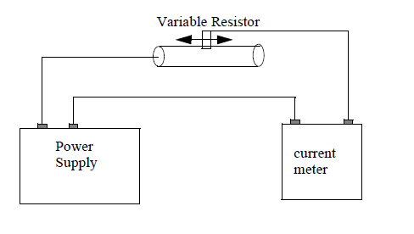
Figure 1: Ohm’s Law circuit

- Begin by using a multimeter to explore the variable resistor. Disconnect the variable resistor from the circuit. Place one of the multimeter probes at one of the end posts of the resistor and one probe on the post on top of the resistor that is electrically connected with the sliding part. By sliding the top piece left and right, you should be able to produce a variety of resistances. Watch the resistance values on the multimeter as you move the slide. Once you are familiar with the variable resistor, construct the circuit shown in figure 1.

- Select a voltage on your power supply and measure the value with the multimeter. Next, vary the resistance and record the current measurement for each resistance value. Measure the resistance with the multimeter and the current with the current meter. Remember to disconnect the resistor from the circuit before measuring resistance. Collect at least ten sets of data. Make a table of current and resistance values. Using Excel, calculate I*R for each measurement. Find the mean value for I*R and estimate your uncertainty. Compute a percent error between your measured value of V and the mean value of I*R. Do your results make sense?

- Select one value of resistance, R, and measure the value with the multimeter. Vary the voltage and measure voltage and current for several measurements. Plot V vs. I and fit a line to the data. Compare the slope of your line-fit to the resistance value chosen for this part of the experiment. Do your results make sense?

II. Series/parallel

In this exercise, you will be exploring the difference between series and parallel. Two or more resistors connected in series is equivalent to a single resistor, Req, whose value is given by

(3)

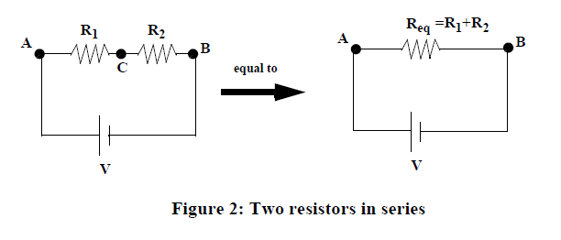
Similarly, two or more resistors in parallel are equivalent to a single resistor, Req, whose value is given by
(4)

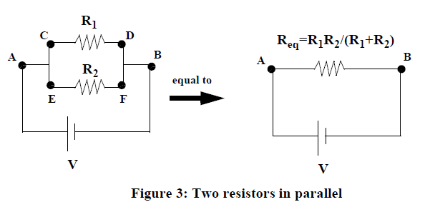
Procedure:

Safety: Be careful to not touch any metal connectors or wires while your power supply is on. Turn the power supply off any time you are not actually taking a measurement. The resistors can become quite hot.

Equipment list: 2 multimeters, several resistors, wires with alligator clips.

You will have two multimeters for this experiment. The tabletop multimeter will be set to measure voltage, and the handheld one will be set to measure current. Please do not change any settings on the meter that is measuring current.

- Connect two resistors in series as seen in Figure 2. Measure the voltage over each resistor (AC, CB) and over both resistors (AB). Measure the current at points A, C, and B (see figure 2 for placement). To measure the current, place the current meter in series at the point desired. For example, the set-up to measure current at point A should look like this:
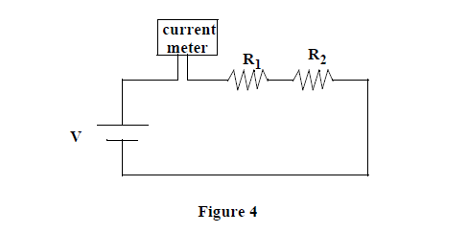
Verify the equation for Req and Ohm’s Law ().
Also show: , and .

- Connect two resistors in parallel as seen in Figure 3. Measure the voltage over each resistor (CD and EF) and over both resistors (AB). Measure the current at the following points: A, D, F, B (see figure 3). Verify the equation for Req and Ohm’s Law. Show that , , , , and .

- Given your resistor values, how much current should pass through R₁ and R₂ in Figure 2? How much current should pass through R₁ and R₂ in Figure 3? Compare your theoretical answers with your measured values.

III. Genecon generator

A generator converts mechanical energy into electrical energy. Typically it is done by rotating a loop of wire inside of a constant magnetic field. That rotating loop will have a varying flux through it, which will create an EMF. This is the principle upon which generators, from large power plants (steam turns a turbine) to hydroelectric plants (falling water is the mechanical source) to bicycle generators which power headlights (rotating wheels are the mechanical source) operate. Of course the conversion is not perfect, there is some efficiency involved. A generator at a power plant may be 70-99% efficient.

In this lab, we will use a hand-held Genecon generator. The source of mechanical power is you, turning a crank. The electrical output can be measured in a number of experiments. Of particular interest is what happens to the power you need to supply as the load on the output changes.

Figure 5: Genecon Generator

Procedure

Equipment list: 1 Genecon generator, Christmas tree lights

- Check that the Genecon cord is plugged in with the pink/orange lead on the top. There is no difference if it is the other way around, but uniformity with all of the Genecons will make referring to things in the procedure easier.
- Connect the output of the Genecon to the multimeter. Connect the pink/orange Genecon lead to the red meter lead. Rotate the handle in all of the different manners (fast, slow, clockwise, counter-clockwise, etc.). How large of a voltage can you create and how?
- Creating a voltage is nice, but it is better to actually do something with it. Put one Christmas light bulb between the leads of the Genecon. Get a feeling for the rotation speed/strength necessary to light the bulb, and how the brightness depends on the rotation. Pick a rotation speed that will be easy to reproduce, and which seems to light the bulb quite well.
- Add a second bulb in series with the first, and try to reproduce the optimum rotation speed you picked above. Do you notice a difference in the rotation necessary to light the two bulbs compared to one bulb?
- Add a third bulb also in series, then a fourth, etc. What is your finding?
- Now go back to the one bulb and get a feeling for lighting it again. Add a second in parallel. After lighting those two, add a third and fourth in parallel. What can you say about the force necessary to rotate the handle with different numbers of bulbs attached. What causes the difference in rotation difficulty? (Think about the bulbs as resistors. What is changing if you keep the same rotation speed, but add more bulbs/resistors in series and parallel?)
- What do you predict would happen if you connected the Genecon leads directly together (so that your resistance is very, very small)? Try it and explain!

