**Hendrix Corner Apartments**

**Buildings A and B**

**(2 Bedroom, 2 ½ Bath)**

Some units may be the mirror image of what is pictured.

Measurements are not exact.

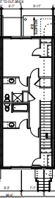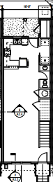

16’

16’

7’4”

12’

9’2”

7’4”

12’

30’1”0”’

10’

4’

’

8’

12’

14’6”

’

9’

5’4”

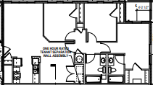

12’

10’

10’

8’5”

6’7”

10’2”

9’

16’

17’

**Hendrix Corner Apartments**

**Building C**

**(3 Bedroom, 2 Bath)**

Some units may be the mirror image of what is pictured.

Measurements are not exact.

10’

16’

16’

12’