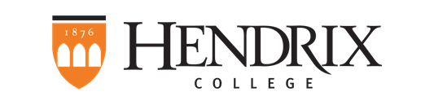

Mellon Departmental Initiative Grant 2017-2018

Please send your completed application as an e-mail attachment to Leslie Templeton. In the email subject field and as the document name, please type: [your department name] 2017-2018 Mellon DIG. Applications are due no later than 5:00 pm on Wednesday, January 31, 2018. You will be notified of receipt of your application.

Please provide all of the following information in roughly two pages:

1. Applicant information:

- Name of Chair
- Academic Department
2. What are the diversity and inclusion challenges identified by your department at the 2016 Fall Faculty Conference and in follow-up discussions?

3. How would your department like to address those challenges?

4. What resources do you anticipate your department will use to address those challenges (e.g., conference travel, visits to other institutions, visits from colleagues or other experts)?

5. How much funding do you request? Detail your budget for this funding.

