Student Instruction Manual for online pre-registration

  - Log in to CampusWeb
Access CampusWeb through the Quick Links menu on the Hendrix home page. Log in using your CampusWeb user name, which is your full email address, and your CampusWeb password.

After logging into CampusWeb, expand the Academics menu of CampusWeb and select “course search”.
The current term will display. If necessary change the term in the drop down list and you should see the message “Add period Open / Drop Period Open”.
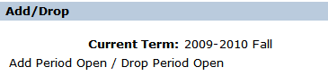

Following the instructions on the screen use the Add/Drop courses or Course Search features to add the course to your tentative schedule.
  - Using the Add/Drop Course link:
At the top of the screen select the Term and Division for which you would like add or drop classes. There is also information about when Add/Drop and Registration periods are open and the number of credits for which you are currently registered.
On the Add by Reference # tab you can register for up to six courses by entering their Fast Search Numbers. If you do not know the Fast Search numbers of the courses you wish to add to your schedule then use the Course Search tab to search for courses:
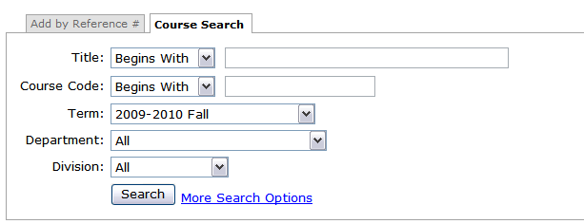
Simply check the “add” box next to the course name and then select the “add Courses” button at the bottom of the screen.

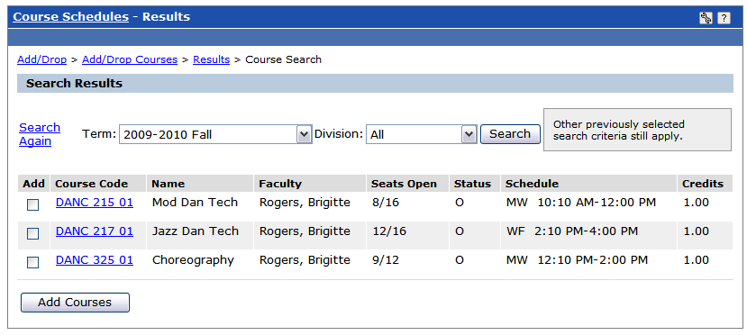
For additional information on a found course, click the Course link in the Course Code column.
During the pre-registration period you can freely add and drop courses until you come up with a tentative schedule. (Exception: The Engaged Citizen and Explorations sections are pre-assigned and may not be changed.) You should build a tentative schedule for both the fall and spring terms.
  - After the course has been added
After you add or drop courses, you will see messages which confirm the action was successful or will list the reason for an unsuccessful action. You can also view the following lists:

Your Schedule (Registered)
This section displays all of the registered classes that you are permitted to drop. Courses that you cannot drop for the selected term and program do not have a checkbox under the drop column.
This section displays information on Course Code, Title, Schedule, Location, and Credits for each registered course. To view Course Details, click on the course title hyperlink.
To drop a course, select the check box next to the course and press the Deny Advisor Approval button. View confirmation that you have successfully dropped a course in the Messages section.

Awaiting Advisor Approval
This section displays all of the classes that require advisor approval before registration.
After the schedule is approved if you are instructed by your advisor to enter your own bid points please see the instructions on page 5.

  - Sample Error Messages
One or more of the following errors displays in the Courses Not Yet Registered section if a course cannot be added directly to your “Registered” list of courses:

Can't Add (missing prerequisite, etc.)
This error displays for a course that you cannot register for because you are missing a prerequisite for the course:
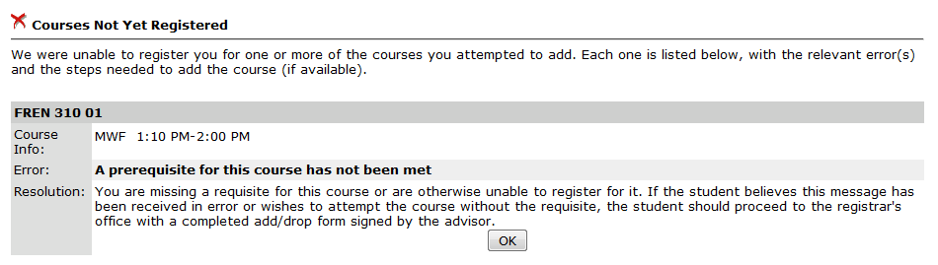
Return to the Course Details to get more information about the course prerequisite. You can also click the Course Search hyperlink to search for a different course.
Click the Ok button to remove this message.

Corequisite Course(s) Required
This error displays for a course that cannot be added until its corequisite courses have been added: 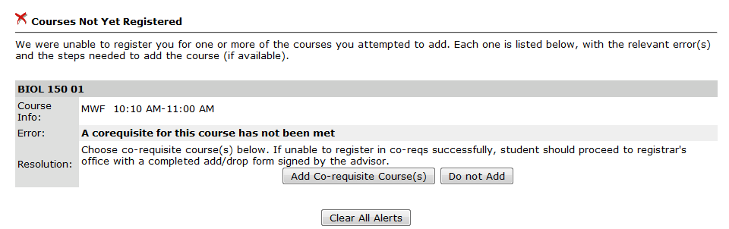

By selecting “Add Co-requisite Course(s)” if there is more than one course that meets the co-requisite then you will see the screen below. By clicking the + beside each lab you can get additional information. When you select one co-req and click “Add Corequisite Course(s)” it will return you to the schedule screen.
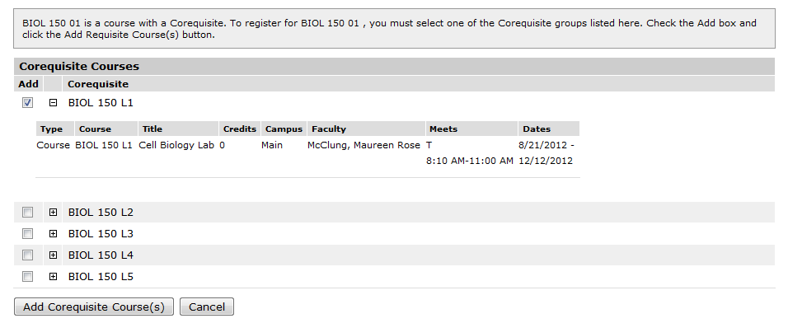

Schedule Conflict, Single Course Conflict
There are two possible error messages when you have a schedule conflict. This error displays for a course that has a schedule conflict with one or more currently pre-registered courses:
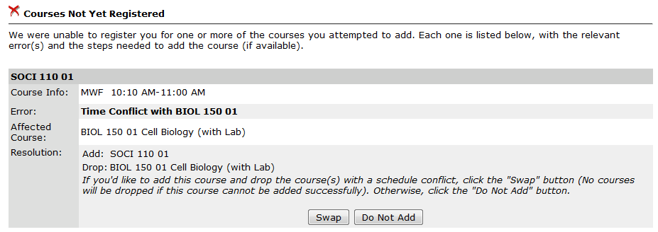
Click the Swap button to drop the course with the conflict and add a new course. Click the Do Not Add button to cancel any action and remove the new course.
However if the conflict is with a registered course (not a pre-registration) then you will see this message and you will not be given the option of swapping the courses:
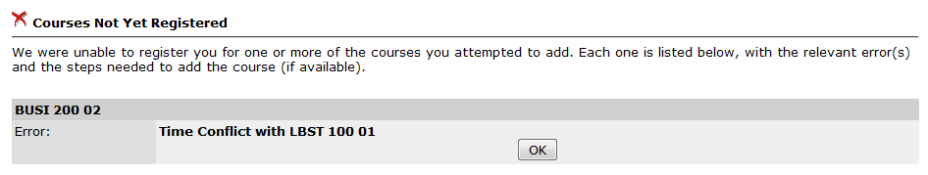

  - Bid Points and Alternate Courses

This section applies to returning students only – not to students who are registering for their first term at Hendrix.

Once your schedule has been approved by your advisor for both terms the bid points and alternate courses process becomes available to both you and your advisor.

You may not exceed your total bid points for a term. Neither bid points nor alternate courses are required on every course although alternate course selection does not cost bid points, so it is advisable to choose alternate courses whenever possible.

Click on the “Bid Points and Alternate Courses” link on the left-hand menu under “Academics”
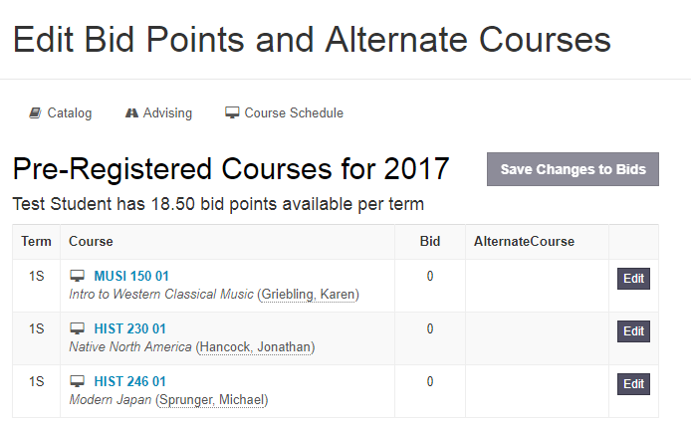

All courses which have been approved by your advisor will be displayed in a form where you can enter bid points and/or alternate courses. If the courses do not appear make sure that your advisor has already approved them. Use the “Edit” link to choose alternate courses from a list of courses for this term.

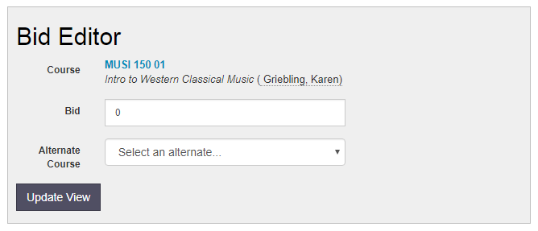
Alternate courses do not perform time conflict checking. If you are dropped from the pre-registered course because of course capacity limits, the Registrar will attempt to place you into the alternate course.

If you have problems allocating points or selecting alternate courses, please seek advice from your advisor.

After bid points and alternate courses have been entered you must click on the “Save Changes to Bids” box to complete the pre-registration process and finalize your course requests.

When finished, you will see a confirmation window. Registration is complete.

