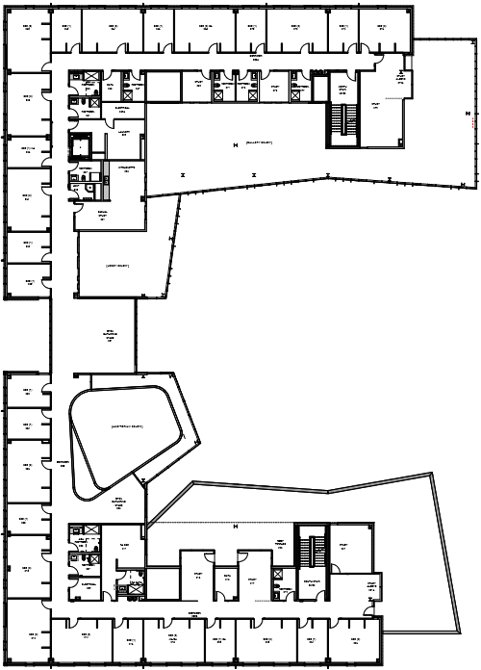

Single

Single

Single

Single

Single

Single

RA

211

Double

Double

Double

Double

Double

Single

Single

Single

Double

Double

Double

Double

Single

Single

Single

Single

Double

Double

Double

Double

Double

260

212

B

B

208

210

206

204

202

250

Study

252

Study0

Study

276

274

272

270

268

2660

264

262

220

218

216

214

Study

Study

226

Study

Study

224

B

222

B

Gathering Space

B

B

Gallery Below

254

256

Open Gathering Space

Lobby Below

Kitchenette

Laundry

B

B

B

B

B

Study

Study

258

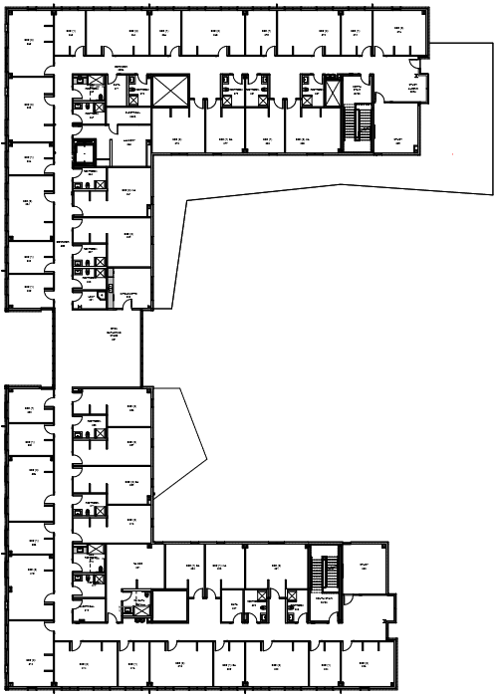

Double

Double

Double

Single

Single

Double

Double

Single

Double

Single

Single

Double

Double

Double

Double

Double

Single

Single

Double

Single

Single

Single

Double

Double

308

303

302

Single

Single

Single

Single

Single

Single

Double

Double

Double

Double

Double

Double

Double

Double

Double

331

325

316

323

326

3241111

3222

320

312

314

Study

304

Open Gathering Space

Study

Study

376

385

383

377

375

Laundry

359

RA350

374

370

372

368

366

364

360

362

354

358

361

356

352

310



306

309

313

307

B

B

RA 321

318

B

B

B



B

B

B

B

B

B

B

Kitchenette

Study

Study

Study

Study