SIMPLE PENDULUMS

OBJECTIVES
The purpose of this lab is to explore the behavior of simple pendulums and use them to determine the height of a building.

INTRODUCTION
A simple pendulum, like the one shown in Figure 1, is an ideal system consisting of a compact mass m suspended from a massless string of length l. If the mass is displaced from the vertical by an angle θ then the pendulum will swing back and forth; it will exhibit simple harmonic motion. The the time to complete one oscillation is know as the period T and is given by the following equation:
$$T=2π\sqrt{\frac{l}{g}}$$
This result has a number of distinctive features:
- the period is independent of the object’s mass,
- the period increases with pendulum length, and
- the period depends on the local value of g, the gravitational acceleration.
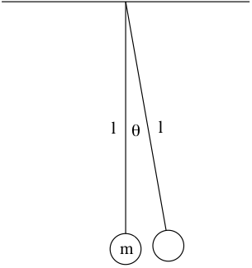
In order for this result to be true the pendulum must obey the small angle approximation: the maximum angle θ that the pendulum makes with the vertical must be small enough that $\sin{θ}\sim θ$. If the angle is too great then the simple expression for the pendulum’s period T will not be correct.
Figure 1: An illustration of a simple pendulum with pertinent physical characteristics labeled.

EXPERIMENT
Use the available apparatus to design and perform experiments to address the topics listed below.
- Investigate the dependence of the pendulum’s period on the pendulum’s length. (There should be a pendulum with a very long string that you can attach in such a way that the pendulum length can be varied.)
- Investigate the dependence of the pendulum’s period on the pendulum’s mass. (There should be two different mass pendulums with which to do this.)
- Investigate the range of angles over which the small-angle approximation holds so that the real pendulum behaves like a simple pendulum.
- Determine the height of MC Acxiom by performing measurements out in the atrium (you know, the part of the building with the giant swing brass ball in it).
When designing your experiments think about what you need to do to perform a precise measurement that changes only one variable at a time. For instance, how could you investigate the pendulum period’s length dependence alone without also probing its angle dependence? Think about the kinds of plots it might be appropriate to make and how best to present them. Remember that the human eye is not good at distinguishing between different curved lines. If you can think of a way to present your data that results in straight lines that would probably be a good thing.

In your lab summary, briefly describe each experiment you performed and discuss the results.

