**Research focus:** Sexual reproduction is the predominant reproductive mode in eukaryotes, and meiosis (cell division that produces sperm and eggs in animals; Fig. 1) is required for sex.



My research studies the evolution and expression pattern of genes that function during meiosis and DNA repair using two emerging model organisms (Fig. 2): bdelloid rotifers and the parasitoid wasp *Nasonia vitripennis.*



**Current research projects:**

***Abstinence only in bdelloid rotifers?*** Bdelloids (Fig. 2 A & B) are strong candidates for a *bona fide* ancient asexual lineage. These small aquatic invertebrates have survived for >40 million years without males, meiosis or sex, which is “scandalous” because they violate the expectation that sex is necessary for long-term survival. To address this controversy:

* We use degenerate PCR, molecular cloning, DNA sequencing and phylogenetic analysis to identify genes in bdelloid genomes that are specific to meiosis. We refer to this as employing the “meiosis detection toolkit” to search for evidence of meiosis and, implicitly, sex.
* We are using real-time PCR to examine gene expression under extreme conditions to identify genes that might be involved in their survival during desiccation and DNA repair.
* We are also developing functional assays to understand the roles of bdelloid genes during reproduction.

***The alternative splice of life in wasps?*** The jewel wasp *Nasonia vitripennis* (Fig. 2B) is a parasitoid wasp: females lay their eggs in the pupae of fleshflies and blowflies*.* We are presently investigating alternative splicing of genes involved in meiosis in the jewel wasp to determine the significance to this phenomenon.

***Molecular evolution of meiotic genes.*** We are annotating of meiotic genes in the genome project of the centipede *Strigamia maritima* (http://www.strigamia-annotation.org/)*,* and we continue to use bioinformatics and phylogenetics to study genome evolution in diverse animals.

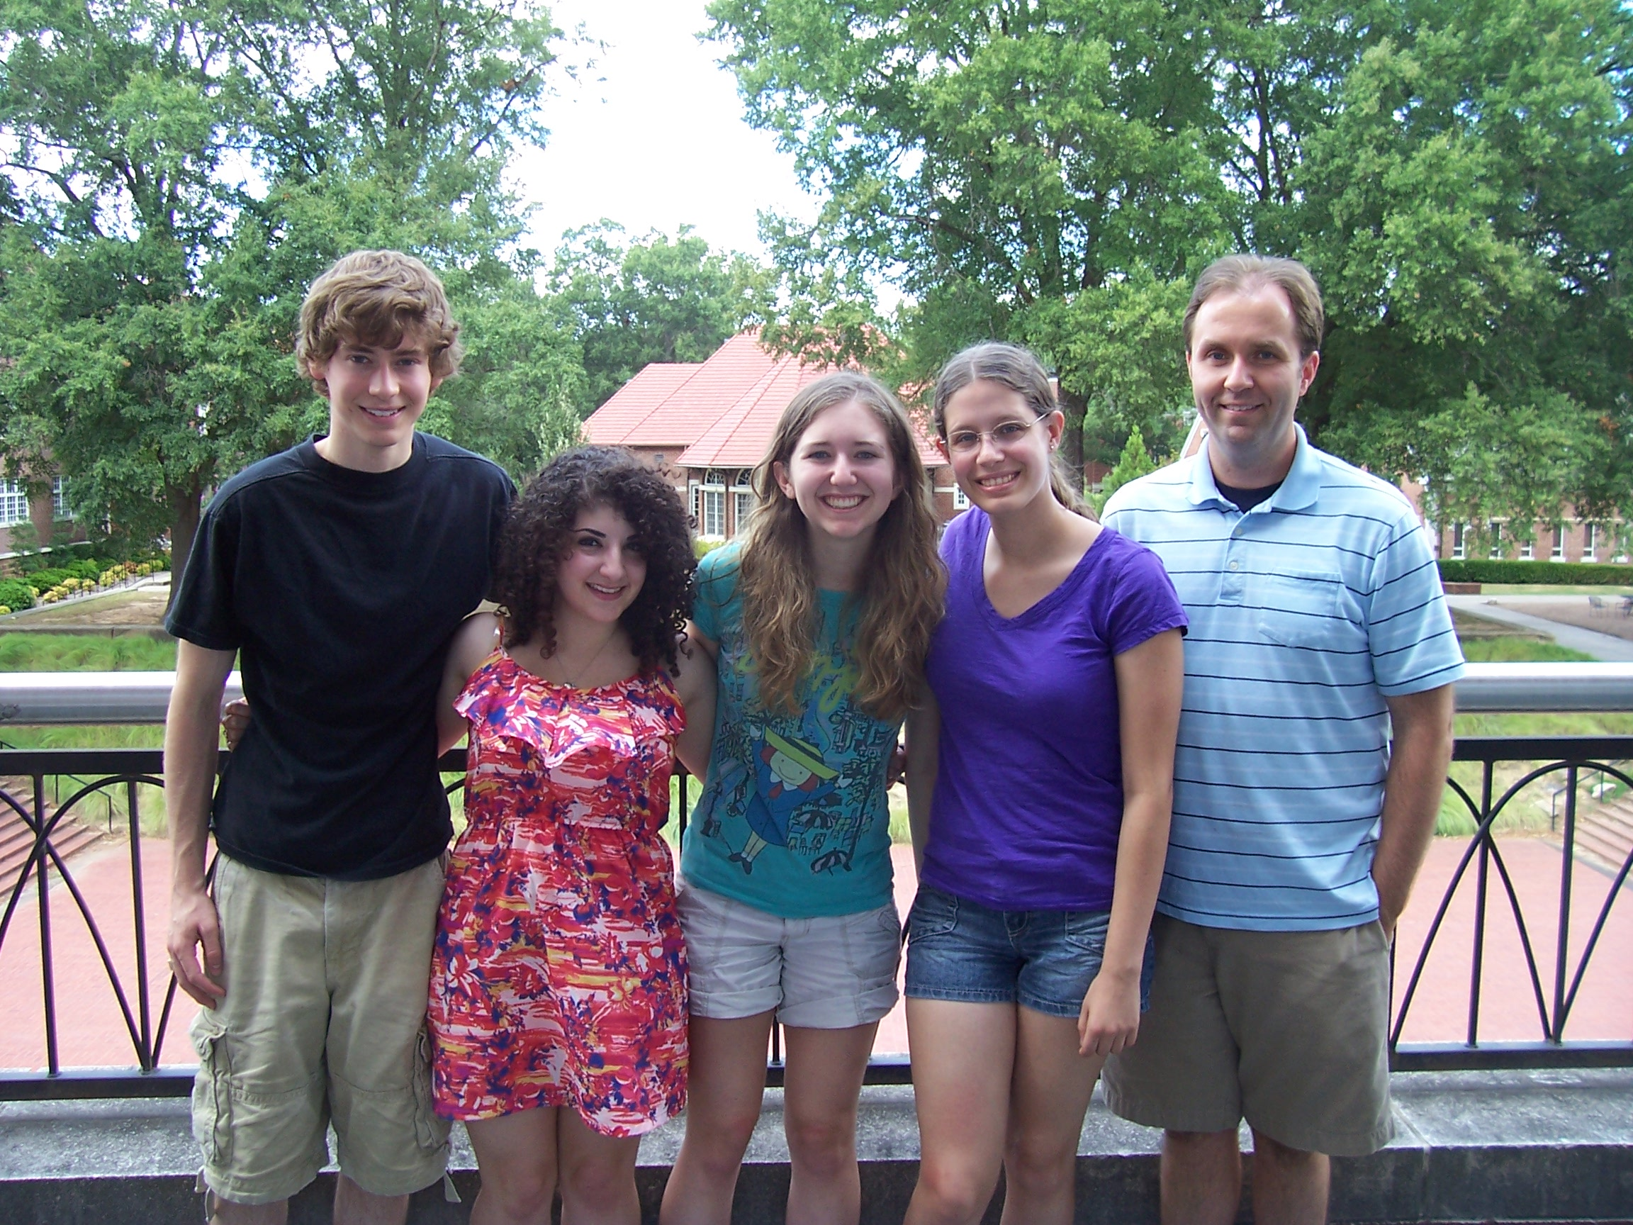

**Schurko Lab 2012-13 (L to R):** James Williams, Youmna Moufarrej, Emily Cariker, Lizzie Goodwin-Horn, Andrew Schurko, Ph.D.

**Publications**

**Schurko, A.M.** 2013. To “bee or not to bee” male or female? An educational primer for use with “The Am-tra1 gene is an essential regulator of female splice regulation at two levels of the sex determination hierarchy of the honeybee.” *Genetics* (In Press).

Hanson, S., **Schurko, A.M.,** Hecox-Lea, B., Mark Welch, D., Stelzer, C.-P. and Logsdon, J. *Inventory and phylogenetic analysis of meiotic genes in monogonont rotifers. Journal of Heredity* (Accepted Feb. 11, 2013).

**Schurko, A.M.,** Mazur, D.J. and Logsdon, Jr., J.M. 2010. Inventory and phylogenomic distribution of meiotic genes in *Nasonia vitripennis* and among diverse arthropods. *Insect Molecular Biology* 19:165-80.

Werren, J.H., Richards, S., Desjardins, C.A., Niehuis, O., Gadau, J., Colbourne, J.K.,…Mazur, D.J…..Logsdon, J.M., Jr….**Schurko, A.M….***et al.*(157 total authors). 2010. Functional and evolutionary insights from the genomes of three parasitoid *Nasonia* species. *Science* 343-348.

**Schurko, A.M.,** Neiman, M. and Logsdon, Jr., J.M. 2009. Signs of sex: what we know and how we know it. *Trends in Ecology and Evolution* 24:208-217.

**Schurko, A.M.,** Logsdon, Jr., J.M. and Eads, B.D. 2009. Meiosis genes in *Daphnia pulex* and the role of parthenogenesis in genome evolution. *BMC Evolutionary Biology* 9:78.

Malik S.-B., Pightling A.W., Stefaniak L.M., **Schurko A.M.,** Logsdon, Jr., J.M. 2008. An expanded inventory of conserved meiotic genes provides evidence for sex in *Trichomonas vaginalis.* *PLoS One* 3:8:e2879.

**Schurko, A.M.** and Logsdon, Jr., J.M. 2008. Using a meiosis detection toolkit to investigate ancient asexual “scandals” and the evolution of sex. *BioEssays* 30:579-589.

Bedard, J.E.J., **Schurko, A.M.,** de Cock, A.W.A.M. and Klassen, G.R. 2006. Diversity and evolution of 5S rRNA gene family organization in *Pythium. Mycological Research* 110:86-95.

Fernando, W.G.G., Zhang, J.X., Chen, C.Q., Remphrey, W.R., **Schurko, A.M.** and Klassen, G.R. 2005. Molecular and morphological characteristics of *Apiosporina morbosa*, the causal agent of black knot in *Prunus* spp. *Canadian Journal of Plant Pathology* 27:364-375.

Li, Y., Kelly, W. G., Logsdon, Jr., J.M., **Schurko, A.M.,** Harfe, B. D., Hill-Harfe, K. L. and Kahn, R. A. 2004. Functional genomic analysis of the ADP-ribosylation factor family of GTPases: phylogeny among diverse eukaryotes and function in *C. elegans. FASEB Journal* 18:1834-1850.

Iranpour, M., **Schurko, A.M**., Klassen, G.R., and Galloway, T.D. 2004. DNA fingerprinting of adult tabanids (Diptera: Tabanidae) and their respective egg masses using PCR-restriction fragment profiling. *Canadian Entomologist* 136:605-619.

**Schurko, A.M.,** Mendoza, L., de Cock, A.W.A.M., Bedard, J.E.J., and Klassen, G.R. 2004. Development of a species-specific probe for *Pythium insidiosum* and the diagnosis of pythiosis. *Journal of Clinical Microbiology* 42:2411-2418.

**Schurko, A.M.,** Mendoza L, Lévesque, C.A., Désaulniers, N.L., de Cock, A.W.A.M., and Klassen G.R. 2003. A molecular phylogeny of *Pythium insidiosum. Mycological Research* 107: 537-544.

**Schurko, A.M.,** Mendoza, L., de Cock, A.W.A.M., and Klassen, G.R. 2003. Evidence for geographic clusters: Molecular genetic differences among strains of *Pythium insidiosum* from Asia, Australia, and the Americas are explored. *Mycologia* 95:200-208.

**Conference abstracts:**

*(names of undergraduate presenter underlined)

Williams, J., Goodwin-Horn, L. and **Schurko, A.M.** *Investigating meiotic gene evolution and ancient asexual “scandals” through phylogenomic analysis of diverse arthropod genomes.* 10th Annual Ecological Genomics Symposium. October 26-28, 2012. Kansas City, MO. (Poster)

Williams, J., Moufarrej, Y., Cariker, E., Goodwin-Horn, L., Menchaca, R., and **Schurko A.M.** *Evolution of meiosis-related genes in diverse arthropods.* University of Arkansas for Medical Sciences Undergraduate Research Symposium. July 25, 2012. Little Rock, AR. (Poster)

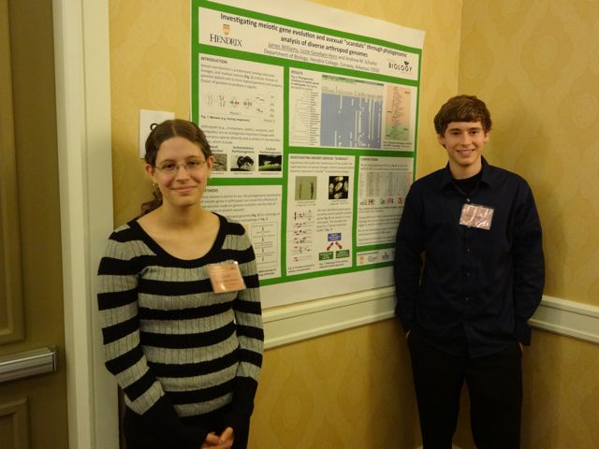

James Williams and Lizzie Goodwin-Horn presenting their research at the 10th Annual Ecological Genomics Symposium in Kansas City (Oct. 26-28, 2012)

**Conference Abstracts (as presenter)**

**Schurko, A.M.,** Mark Welch, D.B., Petruccelli, E.K., Hanson, S.J. and Logsdon, J.M., Jr. Abstinence only? Searching for evidence of sexual reproduction in bdelloid rotifers using a meiosis detection toolkit. XII International Symposium on Rotifera. Berlin, Germany. August 16-21, 2009. (Talk)

**Schurko, A.M.,** Mazur, D.J. and Logsdon, J.M., Jr. Inventory and phylogenomic distribution of meiotic genes in *Nasonia vitripennis* and among diverse arthropods. Annual Meeting of the Society for Molecular Biology and Evolution. Iowa City, IA. June 3-7, 2009. (Poster)

**Schurko, A.M.,** Mark Welch, D.B., Petruccelli, E.K., Hanson, S.J. and Logsdon, J.M., Jr. Abstinence only? Searching for evidence of sexual reproduction in bdelloid rotifers using a meiosis detection toolkit. Evolution of sex & recombination: In theory & in practice (Meeting). Iowa City, Iowa. May 31- June 3, 2009. (Talk)

**Schurko, A.M.,** Stefaniak, L., Lee, K., Ratnappan, R., Hart, R. and Logsdon, J.M. Using the meiosis detection toolkit to seek evidence for sexual reproduction in bdelloid rotifers. American Genetics Association Annual Symposium: Mechanisms of Genome Evolution. Bloomington, Indiana. July 11-13, 2007. (Poster)

**Schurko, A.M.,** Eads, B.D. and Logsdon, J.M. Phylogenomic inventory of meiotic genes in *Daphnia*. Daphnia Genome Consortium Meeting. Bloomington, Indiana. July 8-10, 2007. (Talk)

**Schurko, A.M.,** Lee, K. and Logsdon, J.M. Meiotic genes in bdelloid rotifers provide evidence for sex.Annual Meeting of the Society for Molecular Biology and Evolution. Auckland, New Zealand. June 19-23, 2005. (Talk)

**Schurko, A.M**., Lévesque, C.A., Désaulniers, N.L., Mendoza, L., de Cock, A.W.A.M., and Klassen, G.R. Intraspecific variation in *Pythium insidiosum* based on ITS sequence analysis. Mycological Society of America Annual Meeting. Salt Lake City, Utah. August 25-29, 2001. (Poster)

**Schurko, A.M**., Klassen, G.R, and de Cock, A.W.A.M. Phylogenetic analysis of seven *Pythium* species using the rDNA intergenic spacer. 14th International Botanical Congress. St. Louis, Missouri, USA. July 31-August 5, 1999. (Poster)

Bedard, J., **Schurko, A.M**., Klassen, G.R., and de Cock, A.W.A.M. Evolution of the 5S rRNA gene family in *Pythium.* Annual Meeting of the Society for Molecular Biology and Evolution. Vancouver, British Columbia. June 17-20, 1998. (Poster)