REU program at Virginia Tech Summer 2014

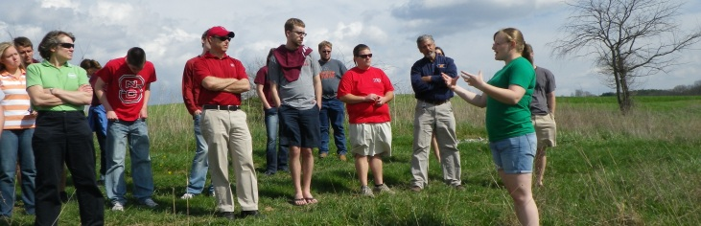

Stream Research, Education, and Management (StREAM) Lab
Definition
The project brings together scientists/educators in CALS and the greater Virginia Tech community to develop a nationally recognized research facility that can be used to attract major competitive funding, improve undergraduate and graduate teaching, and enhance outreach opportunities. The StREAM Laboratory project:
- Promotes collaboration among colleagues across CALS and Virginia Tech;
- Provides live data on a public website;
- Implements a developed monitoring plan and collects data to a database for education and research;
- Increases the number of students utilizing site and data for hands on learning across several scientific disciplines;
- Develops outreach materials for K-12, the general public, and practicing professionals; and
- Is a platform for launching proposals to better understand watershed sustainability.
Objectives
The overall project goal is to remove Stroubles Creek from the Clean Water Act list of impaired waters [303(d) report]. Specific project objectives include the following:
- Improve aquatic habitat within Stroubles Creek, as indicated by a change in the Virginia Stream Condition Index score for the benthic macroinvertebrate community from the current average of 45.3 to >60 for two successive samples;
- Reduce sediment loading from eroding streambanks of Stroubles Creek and an unnamed tributary by removing cattle access from a total of 1.3 miles and by conducting a Priority 4 restoration (reshape and revegetate banks) on 1,800 ft. (0.34 mi.) of stream and a Priority 2 restoration (natural channel design) on 2850 ft. (0.54 mi.);
- Reduce bacteria loadings to the stream by removing cattle access to the stream and restoring forested riparian buffers, thereby, proactively addressing the bacteria impairment, as measured by continued DEQ monthly monitoring at two downstream stations; and
- Assess the effectiveness of three methods of stream rehabilitation; livestock exclusion livestock exclusion with bank reshaping and replanting and, livestock exclusion with natural channel design.
http://www.bse.vt.edu/site/streamlab/

